<https://sweetalert2.github.io/>

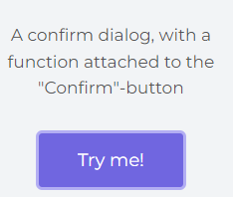

<script src="https://cdn.jsdelivr.net/npm/sweetalert2@11"></script>

<script type="text/javascript">

$(function(){

$(document).on('click','#delete',function(*e*){

    e.preventDefault();

    var link = $(this).attr("href");

    Swal.fire({

            title: 'Are you sure?',

            text: "You won't be able to revert this!",

            icon: 'warning',

            showCancelButton: true,

            confirmButtonColor: '#3085d6',

            cancelButtonColor: '#d33',

            confirmButtonText: 'Yes, delete it!'

}).then((*result*) => {

*if* (result.isConfirmed) {

    window.location.href = link

    Swal.fire(

      'Deleted!',

      'Your file has been deleted.',

      'success'

    )

  }

})

});

});

</script>

Give id **delete** to

<td id=”delete” href=”{{route(“dete”)}}”>delete</td>